COMP7300 Project Reports
“DecoFinance”
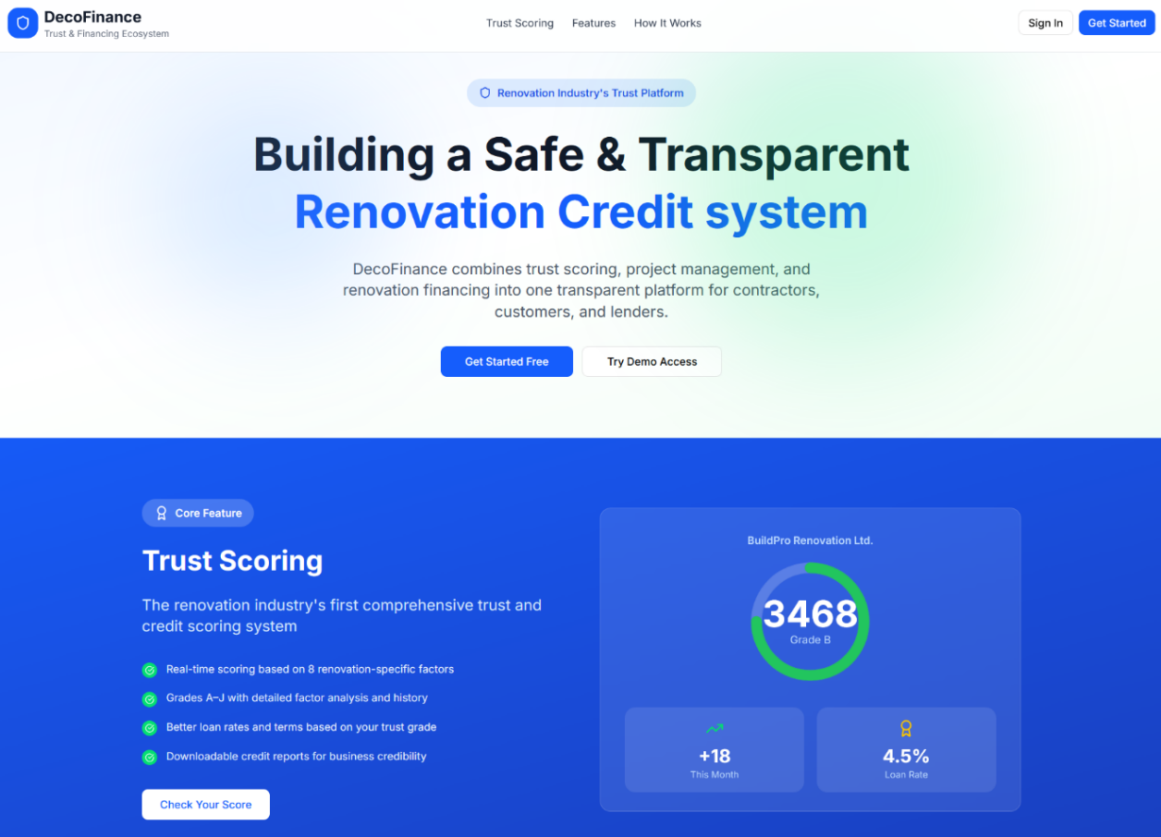
A Credit System for Renovation

LAM Chun-hong, Laurance (25401424) - (Team Leader)
Gao Cheng-you (25401254)
LAM Cheuk-sze, Tracy (25472143)
TIU Kwai-ming, William (25470019)
ZHANG Xin-yue (25409883)
20 April 2026
Table of Contents
Abstract 5
Introduction and Background 7
Business Model 10
Key Algorithm & Assessment Rationale 13
System Architecture and Workflow 18
Frontend Development 20
A. Frontend Presentation Tier (Dual UI Strategy) 20
I. SSR Context (Jinja2: Default App) 20
II. React/Vite SPA (/new-ui: New UI Prototype) 20
III. UI/UX Design & Frontend Implementation 21
B. Default Application: Frontend Refinement & Stability Enhancement 22
C. New UI Prototype: Productized Reference & Advanced Capability Demonstration 23
D. Role-Specific Experience Optimization: 25
E. Frontend Value & Future Iteration Alignment 26
Backend Development 28
A. Project Scope & Architecture 28
B. Core Functional Contributions 28
C. Impact Analysis 28
Database Architecture (The Data Layer) 30
A. Security and Data Integrity 30
B. Optimization via Semi-Structured Data Integration 30
C. Relational Normalization and Entity Relationships 31
Automated Quality Assurance and Systematic Validation 33
A. Unit and Algorithmic Validation (Pytest) 33
B. End-to-End (E2E) UI/UX Verification (Selenium) 33
C. Defect Reporting and Iterative Adjustment 34
D. Empirical Results 35
IT Security and Risks assessment 36
A. Injection Vulnerabilities (SQL/NoSQL & XSS) 36
B. Authentication and Authorization Flaws 36
C. Insecure API Exposure 37
D. Infrastructure and Configuration Vulnerabilities 37
Compliance and Governing 38
A. Regulatory Alignment (Hong Kong PDPO & International Standards) 38
B. IT Governance and Data Lifecycle Protocols 38
Future Development 40
A. Technical Architecture Evolution 40
B. Industry Standardization & Policy Integration 40
C. Go-to-Market (GTM) & Commercialization 41
Conclusion 43
Appendix 44
Appendix: System information 44
Appendix: ER Diagram 44
Appendix: Data Dictionary for Database Design 45
Division of tasks 59

Abstract
The Hong Kong renovation and interior design market faces significant challenges, including widespread trust deficits and financing gaps. Homeowners often struggle to identify reliable contractors and are routinely required to pay high upfront deposits (30–40% of project value), exposing them to financial loss from unfinished projects (known locally as 爛尾裝修). On the other hand, small and medium-sized enterprise (SME) contractors rely on these upfront payments to cover materials and labor. Without them, cash flow constraints can jeopardize project completion. At the same time, these businesses frequently struggle to secure unsecured loans at competitive rates due to their small scale and limited financial track records.
DecoFinance addresses these dual challenges through a digital platform that serves as a trusted intermediary. The system generates a dynamic Trust Score for each contractor based on financial strength, operational stability, qualification and regulatory compliance, and customer reviews and sentiment. This score enables homeowners to select contractors based on their preferences and allows contractors to submit their verified score report to partner financial institutions to apply for loans. Additionally, the platform is architected to support a milestone-gated escrow system, which will securely hold consumer deposits at partner financial institution trust accounts and release payments only upon verified project completion, thereby eliminating the risk of financial loss from abandoned projects.
Built on a modern and modular technology stack, DecoFinance combines Python Flask for backend services with React.js for interactive user dashboards. The system employs SQLite with SQLAlchemy ORM for secure data management, JWT-based authentication, and role-based access control to ensure financial transaction integrity. The platform's architecture prioritizes security, scalability, and maintainability, positioning it for potential future integration with blockchain technologies.
DecoFinance demonstrates how digital platforms can resolve systemic market failures by aligning incentives, creating verifiable trust mechanisms, and expanding financial access for underserved SMEs in the renovation sector.

Introduction and Background
The Hong Kong renovation and interior design market is large but highly fragmented and under-digitized. According to residential transaction data from the Rating and Valuation Department, secondary market sales average approximately HKD 27.8 billion per month. Using a conservative estimation of 1% of transaction value allocated to renovation, this suggests an annual market size of roughly HKD 3.3 billion. Despite this scale, most projects still rely on informal agreements without standard financial protection. For homeowners, renovation is often the second-largest expense after purchasing a property. Yet, current market practices routinely require upfront payments of up to 40% before work begins, and project quotes often lack standardized pricing, leading to unpredictable costs. Without an independent system to safeguard these funds, homeowners face a high risk of financial loss if a contractor fails to complete the work. This has led to the widespread problem of "abandoned projects" (爛尾裝修), which erodes consumer trust and damages the industry's reputation.
Renovation contractors face parallel structural challenges. Most businesses in this sector are small and medium-sized enterprises (SMEs) operating with limited capital and tight profit margins. They depend on upfront customer payments to cover the initial costs of materials and labor. The Consumer Council's research confirms that contractors face challenges including manpower shortages and rising operational costs, while industry practices, such as demanding high upfront deposits, suggest underlying working capital pressures. However, because they often lack physical collateral and formal financial records, traditional banks are reluctant to provide business loans or charge a higher interest rate. This financing gap forces contractors to rely heavily on customer deposits, creating a vicious cycle where both homeowners and contractors are exposed to unnecessary financial risk.
DecoFinance was developed to break this cycle by acting as a neutral platform between homeowners, contractors and financial partners. The system generates a dynamic Trust Score for each contractor based on four key areas: financial strength, operational stability, regulatory compliance, and customer feedback. While the Council proposes a formal accreditation system based on objective metrics (such as financial health and safety compliance) and subjective criteria (such as customer satisfaction and ethical practices), DecoFinance delivers a real-time and digital framework that applies those same standards. By continuously tracking these same competencies, the Trust Score functions as a data-driven accreditation tool that helps consumers select reliable contractors with confidence, while allowing contractors to share their verified performance records with partner financial institutions to apply for working capital loans.
Looking ahead, the platform is designed to include a milestone-based escrow system. This initiative directly addresses a key finding from the Consumer Council: industry stakeholders themselves recommend escrow services as a practical improvement measure. It also aligns with established international practices in markets such as Singapore, Mainland China, and the United Kingdom, where payment protection mechanisms are already standard. By securely holding customer deposits and releasing funds only when both parties verify completed work, this system will eliminate the risk of financial loss from abandoned projects while ensuring contractors receive timely payments for delivered milestones.
As a planned development, DecoFinance operates through a transparent, step-by-step workflow that centralizes project management for all users. Homeowners can browse verified contractors, review performance scores, and track project milestones through a unified dashboard. Contractors use the same platform to monitor payment schedules, upload compliance documents, and apply for financing using their verified track record alongside traditional financial statements. Behind the scenes, the system is built on a secure and role-based architecture that protects sensitive data, enforces strict access controls, and scales efficiently as adoption grows. By replacing informal practices with transparent and data-driven processes, DecoFinance aims to restore trust in the renovation market, improve cash flow for SME contractors, and create a more stable financing environment for the entire industry.

Business Model
Operational Cost Estimation
DecoFinance will be hosted on Hong Kong-based cloud infrastructure. Supporting an estimated 200 verified contractors and 100,000 browsing customers, the platform requires application servers, a managed SQL database, secure document storage, and basic monitoring services. The expected baseline operational cost is approximately HKD 3,500 per month, which serves as the reference expenditure for calibrating the Company On-boarding Subscription Fees.
Revenue Stream 1: Company On-boarding Subscription Fees
Service Offering
Contractors may subscribe on a quarterly, half-yearly, or yearly basis to be listed on the DecoFinance marketplace. Benefits include access to the Trust Score assessment report, visibility to potential customers, and loan referral services through partner financial institutions.
Pricing Structure
The subscription fee is calibrated using a cost-coverage model: each subscribed company pays 7.5% of the baseline monthly operational cost. With a baseline maintenance cost of HKD 3,500 per month, this translates to a subscription fee of HKD 262.50 per company per month (or HKD 787.50 per quarter, HKD 1,575 per half-year, HKD 3,150 per annum).
Under this structure, the participation of just 14 companies fully covers the platform's baseline operational expenditure. With a target base of 200 verified contractors, the first 14 subscriptions recover costs, while the remaining 186 subscriptions generate surplus revenue of approximately HKD 48,000 per month to support platform development, compliance monitoring, customer support, and future feature expansion. This model ensures affordability for SMEs while creating a scalable and sustainable revenue foundation that grows directly with contractor adoption.
Revenue Stream 2: Loan Referral Service Fees
Service Offering
Contractors may apply for loan referrals through the DecoFinance platform. Upon request, DecoFinance will securely forward the contractor’s verified Trust Score report and supporting documents to partner financial institutions for loan consideration.
Regulatory Compliance Framework
In strict adherence to the Money Lenders Ordinance (Cap 163), which prohibits financial intermediaries from charging borrowers any fees, DecoFinance adopts a lender-side monetization model and contractors may request loan referrals free of charge. DecoFinance will request partner financial institutions to appoint the platform as a "third party in relation to the granting of loans" under the Ordinance's regulatory framework. A referral fee will be charged to the financial institution upon successful loan approval.
Pricing Structure
The fee is set at 1% of the loan's annual interest amount (i.e., 1% × APR × principal). For example, for an HKD 1,000,000 loan at 4% APR, the referral service fee would be HKD 400. From the contractor's perspective, the borrowing cost remains unchanged.
This approach addresses the Consumer Council's finding that SME contractors struggle to secure unsecured loans, and DecoFinance provides reference materials for lenders’ risk assessments when approving loans.
Revenue Stream 3: Escrow Administration Fees (Planned Feature)
Service Offering
Customer deposits will be held in a segregated trust account operated by licensed partner financial institution. DecoFinance will charge a processing fee of 0.5% of the Gross Contract Value from each party (customer and contractor). Funds will be released only upon mutual verification of completed project milestones, with all transactions logged immutably for audit purposes.
Regulatory Compliance Framework
DecoFinance has evaluated the regulatory implications of its planned milestone-gated escrow service under the Payment Systems and Stored Value Facilities (SVF) Ordinance (Cap. 584). While the escrow function involves temporary holding of customer funds, the platform is designed to avoid classification as a SVF by adopting a partnership-based operational model. Specifically, DecoFinance will partner with a licensed financial institution to operate the escrow account, in which the licensed partner will hold funds in segregated client accounts, while DecoFinance provides the technology layer for milestone verification, workflow management, and consent tracking. This structure ensures that DecoFinance acts as a service and technology provider, not a fund issuer or holder, thereby avoiding direct SVF licensing requirements while delivering equivalent consumer protection value.
Value Proposition
This fee structure functions similarly to standard payment gateway charges. Given the high risk of upfront deposit loss in the current market, and where the Consumer Council recorded over HKD 277 million in disputed amounts from 2017–2023, this fee is positioned as a necessary insurance premium against financial loss from abandoned projects (爛尾裝修). This initiative aligns with the Consumer Council's recommendation that industry stakeholders consider escrow services as a practical improvement measure, and mirrors established payment protection models in markets such as Singapore, Mainland China, and the United Kingdom.

Key Algorithm & Assessment Rationale
Design Philosophy & Market Alignment
The cornerstone of DecoFinance's value proposition is its proprietary 4-Dimensional Trust Scoring Matrix, engineered to replace subjective and reputation-based contractor selection with a transparent and data-driven assessment framework. Traditional contractor evaluation in Hong Kong relies heavily on word-of-mouth referrals (used by 93% of consumers), unverified marketing claims, and high upfront deposits - practices that contributed to over HKD 277 million in disputed amounts between 2017 and 2023. To address this systemic information asymmetry, DecoFinance's scoring model is structured around four deterministic pillars that directly mirror the Hong Kong Consumer Council's recommended criteria for a contractor accreditation scheme: objective metrics (financial health, regulatory compliance, operational track record) and subjective indicators (customer satisfaction, ethical business practices). The algorithm outputs a raw composite score capped at 1,000 points, creating a granular and auditable benchmark that reduces consumer risk, rewards compliant contractors, and enables standardized risk profiling for partner financial institutions.
The Four-Dimensional Scoring Framework
Each pillar was selected to address a specific market failure documented in the Consumer Council's research:
- Financial Strength (Cap: 400 Points - 40%): Evaluates liquidity, capital adequacy, and debt management using audited financial statements. The algorithm requires verified audit status to apply full scoring multipliers, ensuring data reliability. Sub-metrics calculate a raw score out of 500 (which is then scaled to 400) and include: Registered Capital (max 100), Annual Revenue (max 100), Current Ratio (max 100), Cash Ratio (max 100), and Debt-to-Equity Ratio (max 100). This dimension empowers consumers to identify contractors with robust financial stability, significantly reducing the risk of project delays or abandonment due to insufficient working capital. By making financial health transparent and comparable, homeowners can make informed decisions about which contractors are most likely to complete their projects as promised.
- Operational Stability (Cap: 250 Points – 25%): Evaluates a contractor's business longevity, completed project history, and team size. The scoring model awards higher points to companies operating for five or more years, caps completed project records at 100, and scales workforce points proportionally. By measuring past performance, the algorithm identifies contractors with reliable track records and reduces the likelihood of project abandonment or significant delays. This directly addresses the Consumer Council's finding that 41% of complaints relate to abandonment or non-completion, giving consumers confidence that selected contractors have the capacity and experience to deliver.
- Qualifications & Regulatory Compliance (Cap: 200 Points – 20%): Validated mandatory licenses (e.g., Buildings Department Minor Works Registration), insurance coverage, and Occupational Safety & Health (OSH) certifications. The system requires PDPO-compliant electronic consent before cross-referencing contractor data with government databases and credit bureaus. Valid insurance cover notes and registered OSH officers each contribute 50 points. This dimension ensures that only contractors holding mandatory statutory licenses are permitted to operate on the platform, guaranteeing that all renovation work is conducted in full compliance with Hong Kong's legal and regulatory obligations. This addresses the Council's finding that over 75% of contractors provided legally questionable advice regarding fire safety and structural alterations.
- Customer Reviews & Sentiment (Cap: 150 Points -15%): Incorporates structured post-project ratings (Quality, Pricing and Service Speed) and an internal DecoFinance subjective assessment. Customer ratings are aggregated and scaled to a maximum of 100 points, while administrative reviewers analyze dispute histories, platform communication latency, and verified external feedback to apply up to 50 subjective adjustment points. This dynamic layer ensures scores reflect actual service delivery rather than one-time marketing efforts, aligning with the Council's emphasis on long-term accountability and ethical practices. It also responds to consumer concerns about exaggerated promotions (58%) and high-pressure sales tactics (52%) by rewarding contractors who consistently deliver on their promises.

Scoring Output & Incentive Architecture
The raw composite score (0–1,000) maps to a tiered grading matrix that dictates contractor visibility on the marketplace, search ranking priority, and eligibility for platform services:
Grade | Score Range | Marketplace Visibility & Access
AAA | 900–1000 | Premier visibility, priority search placement, full access to high-value project referrals
AA | 800–899 | High visibility, standard search weighting, full referral access
A | 700–799 | Standard visibility, baseline search weighting, eligible for partner financial institution referrals
BBB | 600–699 | Standard visibility with compliance monitoring flags
BB | 500–599 | Reduced visibility, restricted from premium project categories
B | 400–499 | Restricted visibility, temporary suspension from bidding on high-value projects
C | 0–399 | Blocked from marketplace participation until compliance or performance issues are resolved

This creates a self-regulating incentive structure: contractors are motivated to maintain high operational standards, resolve disputes promptly, and comply with safety regulations, as poor performance directly impacts their visibility, lead generation, and eligibility for financial partner referrals.
Strategic Impact
DecoFinance's algorithm transforms the renovation market from an opaque, trust-deficient environment into a transparent, performance-driven ecosystem. By converting fragmented, unverified contractor data into a standardized, real-time risk profile, the platform bridges the gap between SME contractors and formal financing channels while empowering consumers with a reliable, evidence-based selection tool. This approach operationalizes the Consumer Council's call for industry self-regulation and standardized accreditation, demonstrating how FinTech innovation can resolve systemic inefficiencies and align stakeholder incentives without requiring immediate legislative overhaul.

System Architecture and Workflow
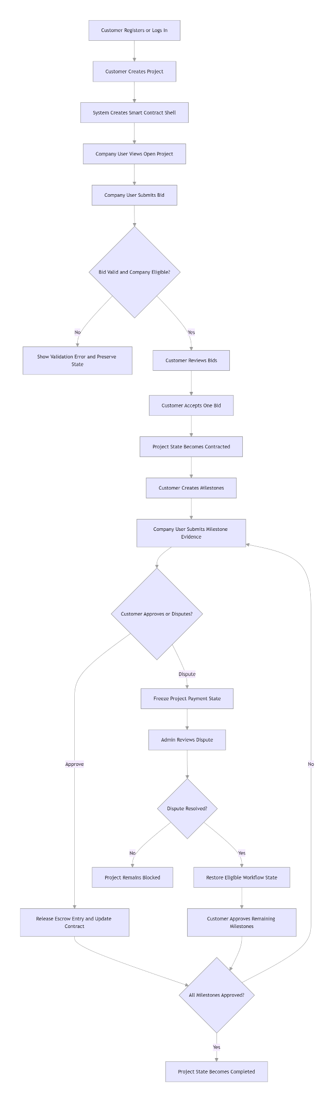
Fig 7: Customer to Company to Admin Main Flow

Frontend Development
Workflow Frontend Implementation (Dual UI Strategy: Default App Refinement + New UI Prototype Development)
UI/UX Design & Frontend Development
- Frontend Presentation Tier (Dual UI Strategy)

SSR Context (Jinja2: Default App)
Implemented full-scale UI refinement and stability enhancement for all frontend HTML pages under the templates directory, covering public-facing endpoints (homepage, login/registration), core functional pages (credit score, company details, project, audit logs and so on). All modifications strictly preserved the original Jinja2 backend template syntax ({% %}/{{ }}) without altering any backend business logic, achieving standardized page layout, unified visual style and visualized compliance labels. This work resolved critical display anomalies (e.g., misaligned form elements, disjointed table layouts, inconsistent button states) across all user roles, ensuring optimal static interaction experience and loading speed for the final demonstration version.

React/Vite SPA (/new-ui: New UI Prototype)
Developed a fully functional, high-fidelity New UI prototype as a productized reference for future iterations, built with React/Vite and fully compatible with the Jinja2 SSR layer. The prototype delivers advanced, role-aligned interactive dashboards and workflows, including:
- Company User Dashboards: Trust score trend visualization, real-time project milestone tracking, and loan application management (aligned with the New UI company dashboard and trust score pages).
- Customer User Workflows: Project creation, bid review, milestone approval, and dispute management (reflected in the New UI project detail and client dashboard pages).
- Admin Audit & Management Tools: Standardized audit log tables, company comparison workspaces, and loan approval dashboards.
All New UI components maintain consistent design language with the Default App, supporting decoupled deployment via the isolated /new-ui route, and integrating advanced component libraries (interactive charts, drag-and-drop upload, real-time progress indicators) without code redundancy.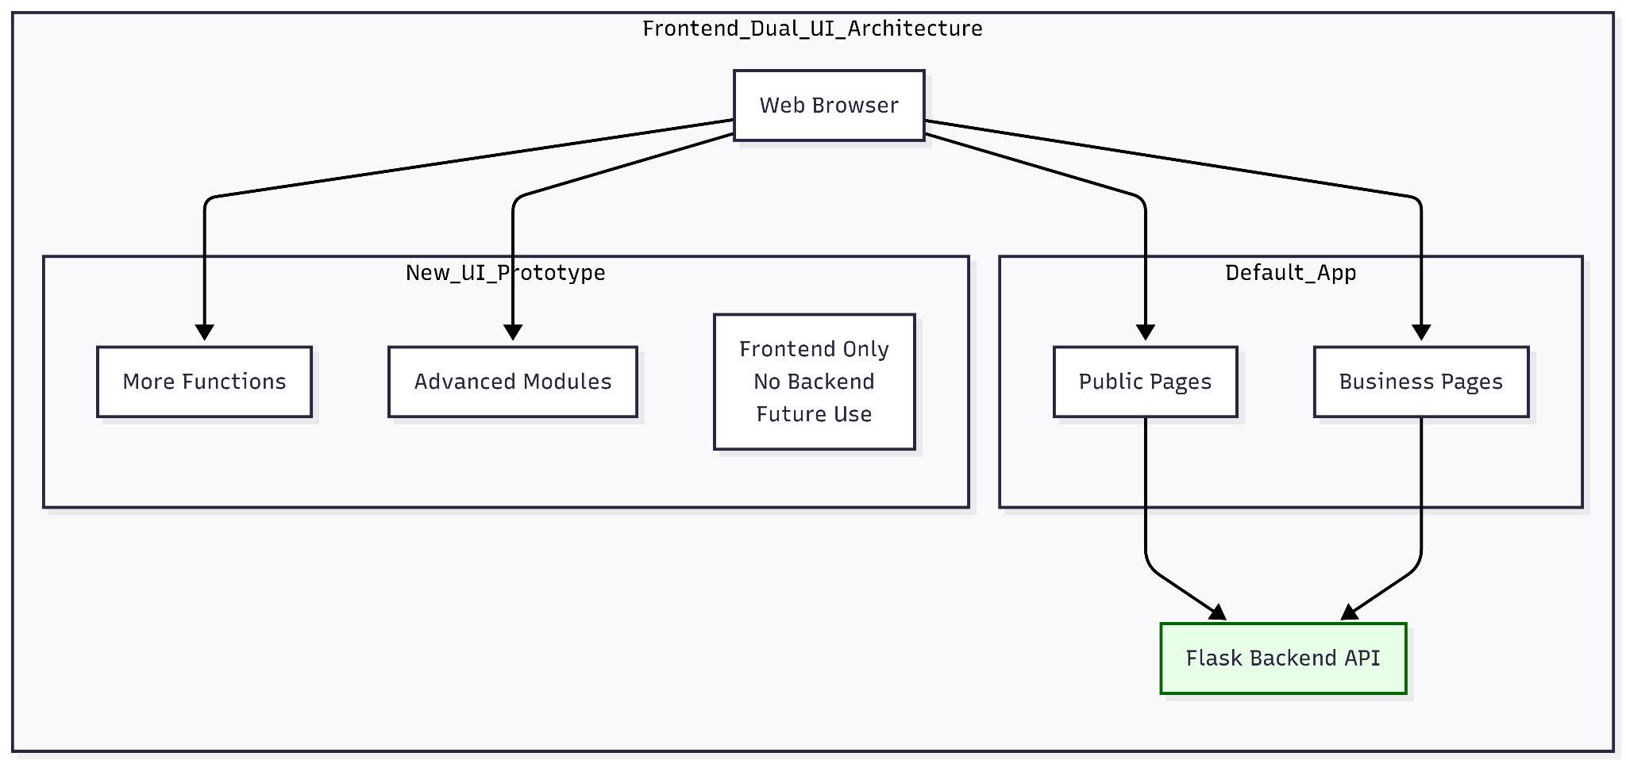
Fig 1: Dual UI Architecture

UI/UX Design & Frontend Implementation
The project adopts a dual-frontend iteration strategy to balance immediate deployment needs (Default App) and long-term productization goals (New UI Prototype). Frontend efforts focus on two core areas: refining the Default App for stable final demonstration, and developing the New UI as a future-ready, feature-complete reference prototype. All modifications strictly adhere to the principle of not altering backend business logic, relying solely on style optimization, layout standardization, and user-centric functional enhancements.

Default Application: Frontend Refinement & Stability Enhancement
As the deployed version for final demonstration, the Default App—originally a backend-focused prototype—required end-to-end frontend refinement to address layout inconsistencies, component display errors, and usability gaps. Key improvements, verified by actual page iterations, include:
- Visual Standardization: Unified global design language across all user-facing pages, including standardized button styles, font hierarchies, color palettes, and spacing rules to eliminate visual fragmentation.
- Real Examples: Consistent button styling was applied to the Accept Bid/Submit Milestone buttons on the project detail page, the Open Dispute button on the dispute submission form, and the Approve/Reject buttons on the admin loan review page, ensuring a cohesive visual experience across customer, company, and admin roles.
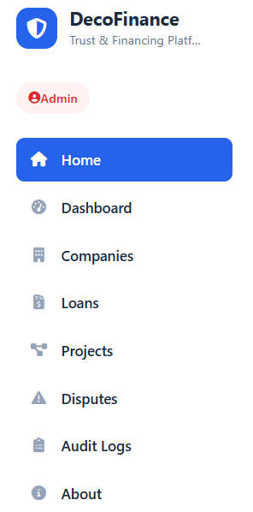
Fig 2: Standardized Admin Role Sidebar Navigation in Default Application
- Display Issue Resolution: Rectified functional display anomalies such as misaligned form elements, unresponsive button states, messy text wrapping, and disjointed data table layouts, ensuring core operational workflows (project bidding, milestone approval, loan application, audit logging) are free of frontend obstacles.
- Real Examples: Table layout errors on the audit logs page were fixed by standardizing column widths, text alignment, and adding alternate row backgrounds; form element misalignment on the create project page was resolved by restructuring field grouping and spacing.
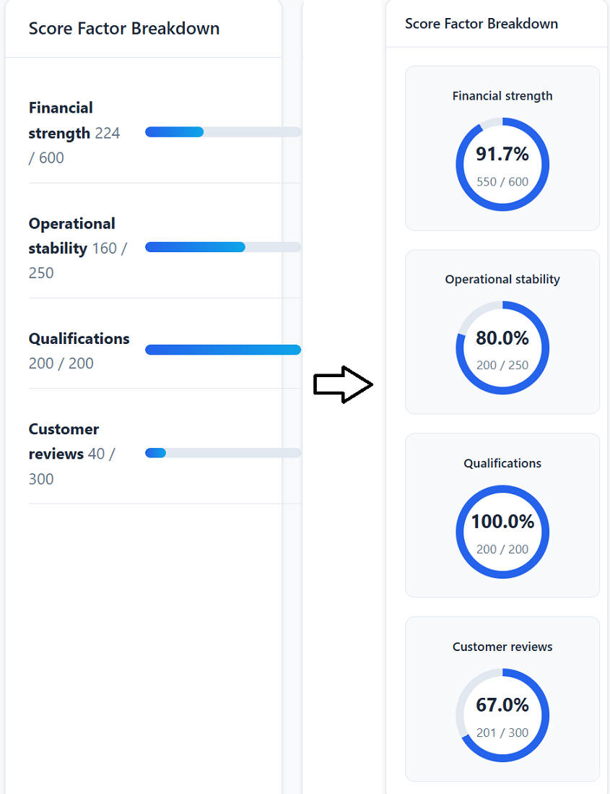
Fig 3: Trust Score Factor Breakdown UI Optimization in Default Application
- Cross-role Adaptation: Tailored frontend adjustments for customer, company, and admin user roles—optimizing form layouts for enterprise data entry, simplifying project displays for customers, and standardizing audit log tables for administrators—to align with role-specific operational needs.
- Real Examples: The company profile page was optimized to display trust score progress bars and compliance status clearly for enterprise users; the admin companies list page was adjusted to show action buttons (view/edit/verify) for efficient enterprise management.

New UI Prototype: Productized Reference & Advanced Capability Demonstration
Developed as a comprehensive, high-fidelity frontend reference prototype, the New UI embodies the project’s full UI/UX design vision, serving as a direct blueprint for future iterations with advanced usability and visualization features, fully aligned with actual platform workflows:
- Holistic Visual System: Implemented a cohesive design system with role-aligned visual cues—calming low-saturation palettes for customer-facing pages (reducing transactional anxiety), efficient high-contrast layouts for company operations, and structured data-dense interfaces for administrators—ensuring consistency across the entire user journey.
- Real Examples: The company dashboard features a 7-month trust score trend line chart for intuitive performance tracking; the customer project page uses clear milestone status labels and progress bars for transparent project management.
- Advanced Functional Visualization:
- Trust Score & Credit Reporting: Designed a comprehensive trust score system with multi-dimensional breakdown (payment history, project completion, compliance, financial stability, OSH/ESG performance), interactive score trend charts, and detailed credit reports, as shown in the New UI trust score page.
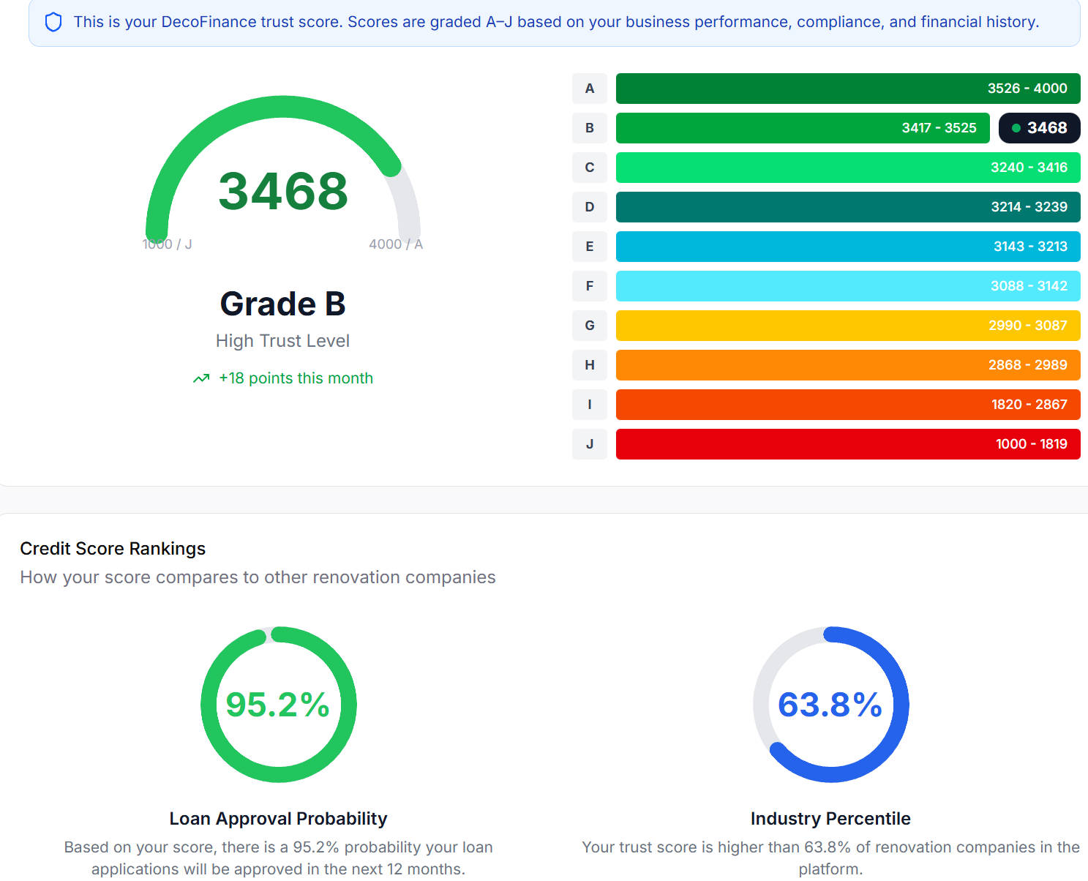
Fig 4: New UI Prototype Trust Score Dashboard
- Milestone Progress Tracking: Built linear progress indicators with phase-specific color coding, real-time status updates, and evidence submission workflows, enabling users to track project advancement briefly (implemented in the New UI project detail and smart contract pages).
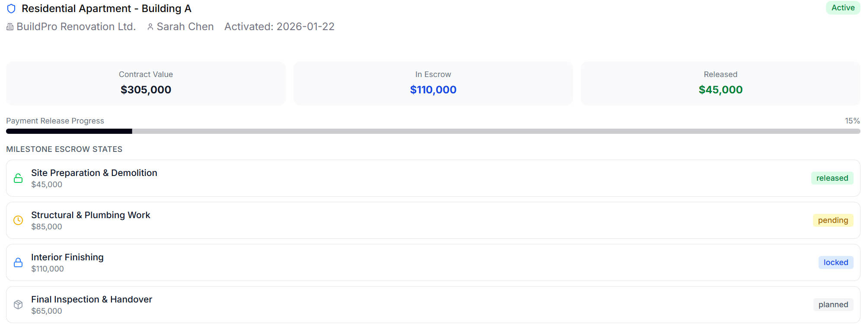
Fig 5. New UI Prototype milestone & escrow management interface with progress tracking.
- Compliance & Security Reinforcement: Integrated prominent compliance labels, security icons, and escrow balance visualizations to reinforce capital safety guarantees, addressing the core trust pain point of the renovation finance scenario (applied in the New UI project contract and company profile pages).
- Streamlined Project & Loan Management: Optimized project marketplace layouts, bid submission workflows, and loan application dashboards with real-time status feedback, credit-based rate displays, and logical module grouping—reducing operational friction for enterprise users (as shown in the New UI project marketplace and loan application pages).

Role-Specific Experience Optimization:
- Customer-Focused Design: Prioritized critical information (contractor trust scores, escrow terms, milestone status) on project detail pages, simplified form fields for registration/login, and enhanced readability of high-value transaction details (aligned with the New UI customer project and company search pages).
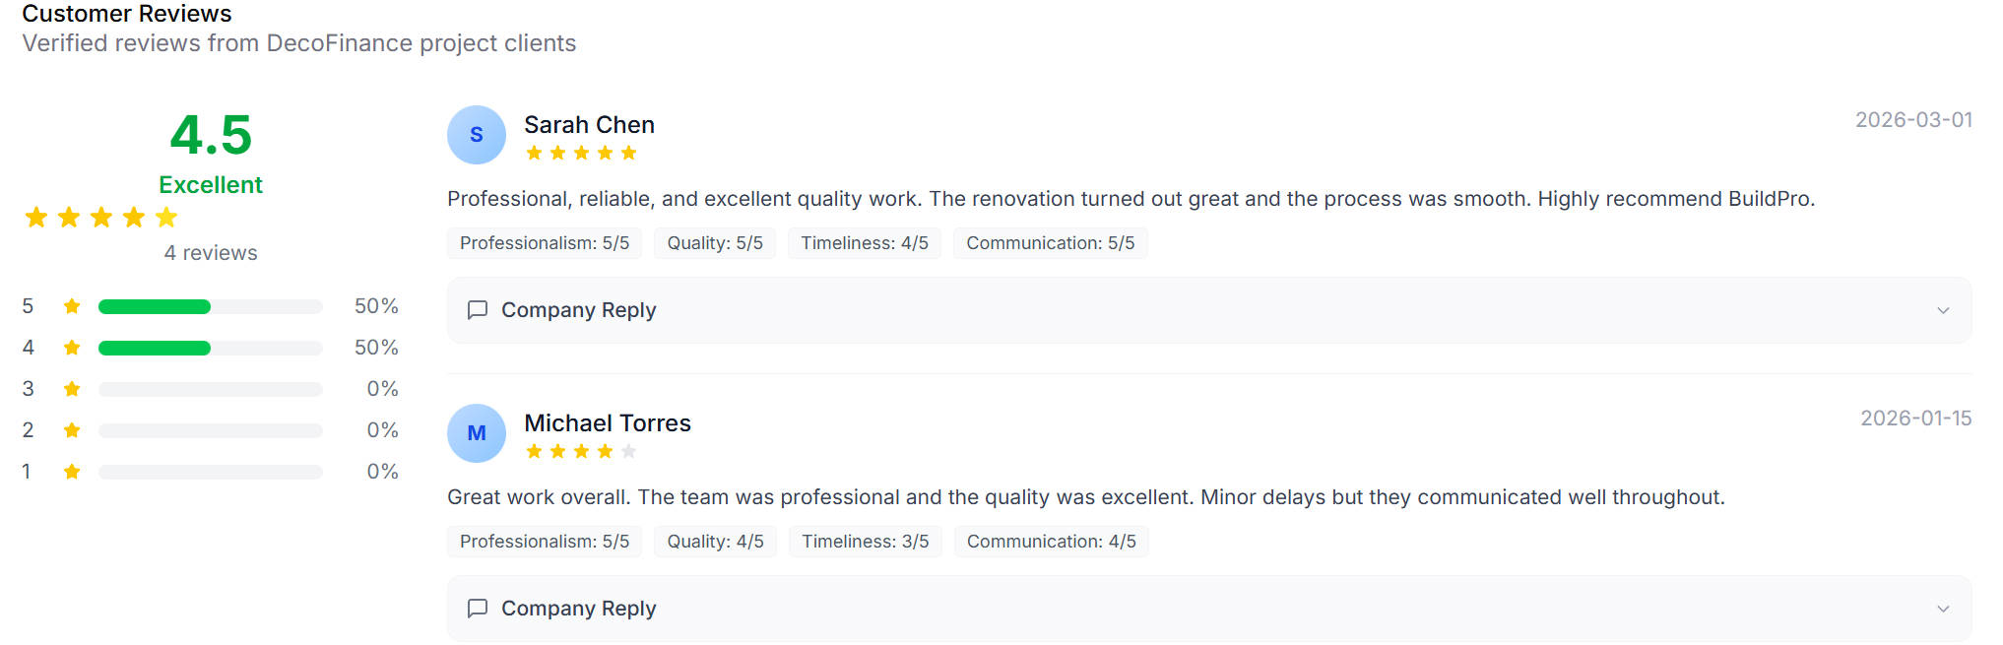
Fig 6. New UI Prototype customer reviews module with verified feedback and rating breakdown.
- Enterprise Efficiency Tools: Restructured business forms (bid submission, milestone application, loan requests) with logical field grouping, standardized data entry templates, and responsive layouts to support high-frequency enterprise operations (implemented in the New UI company dashboard and loan application pages).
- Admin Workflow Enhancement: Developed standardized data tables for audit logs and compliance records with alternate row shading, consistent column alignment, and intuitive operation button grouping—streamlining administrative workflows and reducing error rates (reflected in the New UI audit logs and admin company management pages).

Frontend Value & Future Iteration Alignment
This dual-frontend approach delivers immediate and long-term value: the refined Default App ensures stable, usable frontend performance for final demonstration, resolving critical display issues while maintaining core backend functionality. The New UI prototype, as a feature-complete product reference, encapsulates advanced UI/UX best practices and user-centric design considerations—providing a direct blueprint for future iterations to elevate the platform’s usability, trust signals, and operational efficiency. All frontend work adheres to the project’s technical constraints (no backend logic modifications) and aligns with the overarching goal of creating a transparent, secure, and user-friendly renovation finance ecosystem.

Backend Development

Project Scope & Architecture
Stack: Flask, Jinja2, SQLite (Backend); React/Vite (UI Overview Sub-project).
Architecture: Layered design using Data Models, Service Layer, Blueprint Routes, and Template Views.
Bilingual Support: Full EN/ZH parity across core business templates.

Core Functional Contributions
- Company Verification System (New Domain)
Implemented a comprehensive verification workflow including bank integration, KYC tracking, and referral management.
Developed supporting database schemas, services, and multi-language routing/views.
- Company Document Management (New Domain)
Engineered a robust document handling system for uploading, categorizing, and associating business documents with renovation companies.
Integrated document views into existing company profiles and management forms.
- Credit Scoring & Intelligence (Enhanced)
Optimized scoring algorithms and reporting services to provide deeper insights into company creditworthiness.
Enhanced comparative analytics and report visualization templates.

Impact Analysis
Domain Expansion: Successfully bridged the gap between company data and formal credit verification.
Delivery Quality: Bilingual parity ensures readiness for international collaboration and demo presentations.
Maintainability: Adherence to modular service-oriented architecture reduces future technical debt.

Database Architecture (The Data Layer)
The persistence layer of the system is architected upon the SQLite engine, abstracted through the SQLAlchemy Object-Relational Mapper (ORM). This selection was driven by the need for a lightweight yet robust relational structure capable of maintaining high ACID (Atomicity, Consistency, Isolation, Durability) compliance during the rapid prototyping and local testing phases of the project. All data structure and dictionary are available in appendix pages.

Security and Data Integrity
By utilizing SQLAlchemy as an abstraction layer, the application implements a proactive security posture against SQL Injection (SQLi)—a critical vulnerability in Fintech environments. The ORM’s native use of automated parameter binding ensures that user-supplied input is treated strictly as data rather than executable code, effectively neutralizing the risk of unauthorized database manipulation. This structural safeguard is foundational to maintaining the integrity of the credit scoring and loan application records.

Optimization via Semi-Structured Data Integration
A significant challenge in the system’s design was the management of media-heavy metadata, specifically the storage of multiple Amazon Web Services (AWS) S3 evidence URLs associated with project milestones. Traditional relational normalization would require the implementation of numerous junction tables, which often introduces significant latency during complex JOIN operations and increases the complexity of the data access layer.
To optimize performance, the architecture leverages SQLAlchemy JSON columns to store serialized arrays directly within the primary relational entities. This "hybrid" approach—combining traditional relational keys with semi-structured JSON payloads—offers several key advantages:
- Reduced Page Hydration Latency: By embedding evidence metadata within the parent record, the system minimizes the number of database queries required to render complex views.
- Atomic Conformity: Data remains logically coupled with its primary key, ensuring that evidence logs are always retrieved in context with their respective milestones.
- Schema Flexibility: The JSON structure allows for the futureproofing of the metadata schema, accommodating evolving evidence requirements without necessitating disruptive database migrations.

Relational Normalization and Entity Relationships
Beyond the semi-structured storage, the core schema adheres to strict normalization standards to prevent data redundancy. The Entity-Relationship Diagram (ERD) is centred around a hierarchical flow where the Project entity serves as the macro-root.
This root manages a 1-to-Many relationship with downstream entities such as Project_Bids and Project_Milestones. Furthermore, the decoupling of the User authentication identity from the Company_Profile operational data ensures a modular design, facilitating clear separation of concerns between identity management and corporate credit evaluation.
Simplified ERD (detail version in appendix)
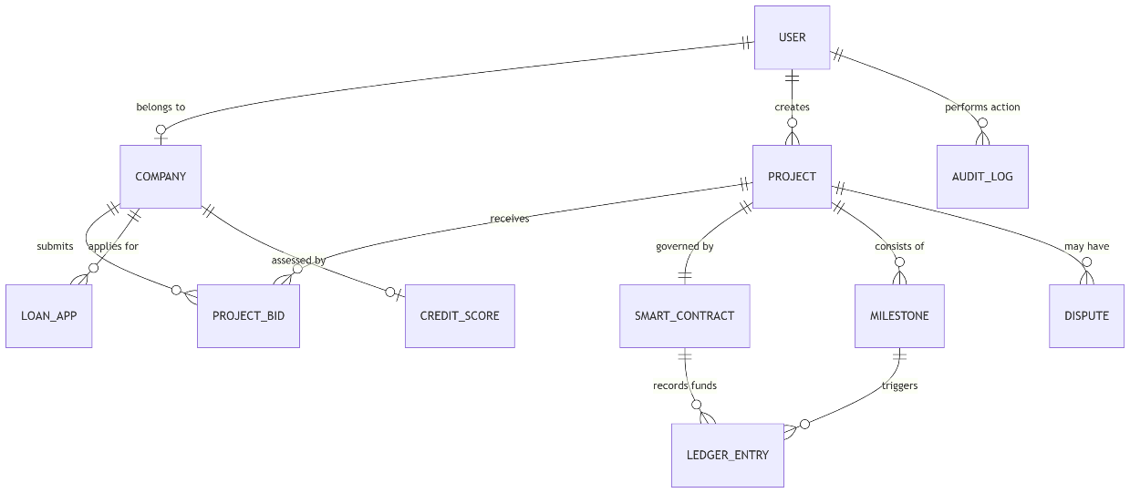
Core Entity-Relationship Logic:
- Identity vs. Profile Separation: A strict 1-to-1 relationship between User and Company_Profiles ensures that authentication remains decoupled from corporate operational data (e.g., BR numbers, Trust Scores).
- Relational Hierarchy: The Projects table acts as the macro-root, maintaining 1-to-Many relationships with Project_Bids and Project_Milestones.
- The Immutability Layer: Inspired by blockchain principles, the EscrowLedgerEntry and AuditLog entities are engineered as Append-Only structures. Programmatic restrictions at the ORM lifecycle layer block UPDATE/DELETE operations, ensuring that every financial mutation—such as loan issuances or escrow releases—is chronologically and cryptographically traceable.

Automated Quality Assurance and Systematic Validation
In a high-stakes Fintech ecosystem, software reliability and transactional integrity are paramount. To address these requirements, a multi-tiered Automated Quality Assurance (QA) framework was implemented, specifically aligned with the ISO/IEC 25010 standards for "Functional Suitability" and "Reliability". This framework ensures that both algorithmic outputs and user interfaces remain resilient under diverse operational conditions.
- Unit and Algorithmic Validation (Pytest)
The core computational engine, specifically the credit scoring logic in services/credit_scorer.py, was subjected to rigorous unit testing:
- Methodology: The suite utilized mathematical mocking to isolate algorithmic logic from external database dependencies, ensuring pure functional verification.
- Boundary Value Analysis: Systematic assertions were performed on boundary parameters to ensure the correlation between corporate inputs (e.g., registered capital) and weighted credit scores remained consistent. This prevents "logic drift" and ensures the engine adheres to predefined business rules.
- End-to-End (E2E) UI/UX Verification (Selenium)
To validate critical user paths, an industrial-strength Selenium WebDriver suite was developed. This suite simulates real-world behaviour within the platform, focusing on two primary scenarios:
Scenario 1: The Project Lifecycle (Customer & Company)
- Workflow: Validates the flow from project creation by a customer to bid submission by a Company, and the final awarding of a contract.
- Integrity: Asserts that database states (e.g., Project Status) update correctly across different user sessions.
Scenario 2: Reviewer Dashboard & Document Integrity
- Deterministic State Management: Implemented a conftest.py fixture for a Data Seeding protocol, resetting the database to a known state before each cycle to eliminate "flaky" results.
- Asynchronous Resilience: To manage dynamic web page hydration, the suite utilizes Explicit Waits and XPath selectors. A robust "Re-finding" logic was engineered to resolve StaleElementReferenceException errors during asynchronous table refreshes.
- Integrated File System Validation: Utilizing a Temporary Directory Strategy, the suite intercepts and verifies that the backend successfully exports the PDF Comparison Report. It programmatically asserts the file is present and contains non-zero-byte data, ensuring the export engine is fully functional.
- Defect Reporting and Iterative Adjustment
A critical component of the QA phase involved identifying technical regressions and providing actionable feedback for further development. During the testing of the Reviewer Dashboard, two primary issues were identified and addressed:
- State Synchronization Errors: Initial tests revealed that the UI did not always reflect immediate database updates following a "Status Select" action.
  - Adjustment: Recommended the implementation of additional AJAX callbacks to the developer to ensure the UI remains synchronized with the backend state without requiring a full page reload.
- DOM Volatility (Stale Elements): Frequent StaleElementReferenceExceptions were detected during rapid navigation.
  - Adjustment: The Selenium script was adjusted to include a looping "try-except" mechanism to re-locate elements. These findings were documented to assist programmers in refining the unique ID assignment for front-end components to improve overall system testability.
- Empirical Results
The deployment of this framework yielded a 100% pass rate across all critical modules.
Test Category | Scope | Metric | Status
Algorithmic | Credit Scoring Logic | Accuracy & Boundary Consistency | PASSED
User Interface | Reviewer Dashboard | Navigation & Element Interaction | PASSED
Data Export | PDF Generation | File Presence & Data Integrity | PASSED

Test Report Screenshot
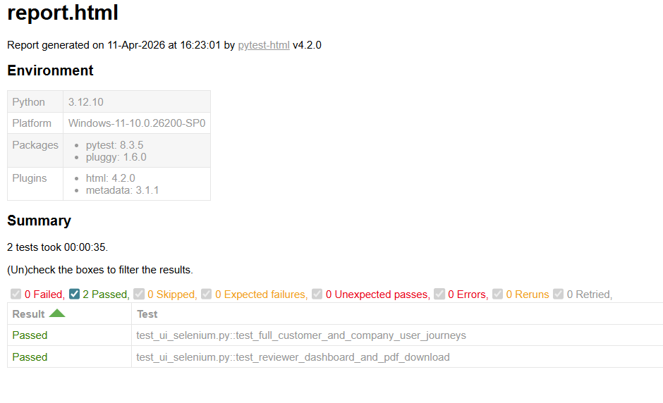
The success of these tests confirms that the platform’s critical workflows are stable, resilient, and ready for a secure Fintech deployment.

IT Security and Risks assessment
A high-level threat modeling analysis of the current software architecture reveals four critical security vectors. For each vector, a structured mitigation roadmap is established to transition from the current baseline to an advanced, enterprise-grade security posture.

Injection Vulnerabilities (SQL/NoSQL & XSS)
- Current Security Posture: The platform utilizes parameterized queries via ORM (Object-Relational Mapping, e.g., SQLAlchemy) to neutralize basic SQL injection attempts. Input validation is performed at the application layer for primary data entry points.
- Future Hardening Strategy: Implement a robust Web Application Firewall (WAF) and transition to strict DevSecOps pipelines where Static Application Security Testing (SAST) and Dynamic Application Security Testing (DAST) are automated. Enforce strict Content Security Policies (CSP) and context-aware output encoding to categorically eliminate Cross-Site Scripting (XSS) vectors across the UI. This aligns directly with the mitigation guidelines stipulated in the OWASP Top 10 (2021) A03:2021-Injection and A03:2021-Cross-Site Scripting.

Authentication and Authorization Flaws
- Current Security Posture: The system employs JWT (JSON Web Tokens) or session-based cookies for stateful user authentication, coupled with basic Role-Based Access Control (RBAC) separating Homeowners, Contractors, and Administrators.
- Future Hardening Strategy: Adopt a Zero-Trust Architecture in accordance with NIST SP 800-207. Implement Multi-Factor Authentication (MFA) as mandatory for all elevated actions (e.g., milestone approvals, fund disbursements). Transition to Attribute-Based Access Control (ABAC) to enforce contextual policies (e.g., location, time) and ensure continuous token validation with aggressive expiration and rotation protocols to mitigate risks identified in OWASP A07:2021-Identification and Authentication Failures.

Insecure API Exposure
- Current Security Posture: RESTful API endpoints are secured via standard HTTPS/TLS encryption and basic endpoint authorization checks, preventing unauthorized direct data access.
- Future Hardening Strategy: Deploy an Enterprise API Gateway to enforce rate limiting, payload inspection, and anti-DDoS measures. Implement comprehensive API discovery and schema validation (e.g., OpenAPI standard enforcement). Regular penetration testing aligned with the OWASP API Security Top 10 (2023) must be institutionalized to comprehensively address API1:2023 Broken Object Level Authorization (BOLA) and API3:2023 Broken Object Property Level Authorization.

Infrastructure and Configuration Vulnerabilities
- Current Security Posture: The application is hosted on containerized instances with environment variables managing secret keys. Periodic manual updates are applied to base images and dependencies.
- Future Hardening Strategy: Migrate strictly to Infrastructure as Code (IaC) utilizing tools like Terraform, paired with continuous configuration drift detection. Integrate automated secret management systems (e.g., Azure Key Vault or HashiCorp Vault) to dynamically rotate credentials. Enforce strict network micro-segmentation, isolating public-facing web instances from internal database clusters and escrow-processing workers, thus rectifying OWASP A05:2021-Security Misconfiguration vulnerabilities.

Compliance and Governing
To establish institutional trust, the platform must adhere to stringent regulatory architectures, primarily focusing on the Hong Kong regulatory landscape.

Regulatory Alignment (Hong Kong PDPO & International Standards)
- Hong Kong PDPO Compliance: The system’s data collection mechanisms must strictly adhere to the Cap. 486 Personal Data (Privacy) Ordinance, specifically Schedule 1 (Data Protection Principles). Compliance mandates explicit, informed consent prior to collecting financial histories and identity documents (DPP1 - Purpose and Manner of Collection), ensuring stringent data minimization (DPP2 - Accuracy and Duration of Retention), and enforcing explicit restrictions on cross-marketing utilize (DPP3 - Use of Personal Data) without opt-in consent.
- Global Benchmarking: To satisfy tier-one banking risk matrices, the platform’s data governance extends beyond Hong Kong. It will cross-reference GDPR (Regulation (EU) 2016/679), explicitly incorporating Article 17 (“Right to erasure”) and Article 20 (“Right to data portability”). Concurrently, standardizing against ISO/IEC 27001:2022 (notably Clauses 5 “Leadership/Policies” and 8 “Operation”) is mandatory to establish an independently certifiable Information Security Management System (ISMS).
- DecoFinance has evaluated the regulatory implications of its planned milestone-gated escrow service under the Payment Systems and Stored Value Facilities (SVF) Ordinance (Cap. 584).

IT Governance and Data Lifecycle Protocols
- Secure Data Lifecycle Management: Implementation of end-to-end encryption for Data at Rest (using AES-256) and Data in Transit (TLS 1.3 as recommended by IETF RFC 8446). PII and financial records must be tokenized or pseudonymized in the core analytical datasets, ensuring GDPR Article 32 (Security of Processing) compliance.
- Continuous Auditing & Logging: Deploy centralized, immutable logging servers (e.g., ELK stack or Splunk) configured for WORM (Write Once, Read Many) compliance to meet the evidentiary standards of the Hong Kong Monetary Authority (HKMA) Supervisory Policy Manual (SPM) TM-E-1 on Risk Management of E-banking. Every critical transaction—bidding, smart contract execution, and milestone approvals—must generate cryptographic audit trails to facilitate dispute resolution and regulatory audits.

Future Development
The platform’s evolution is structured across three interconnected pillars, driving technological maturity, industry standardization, and aggressive market capture.

Technical Architecture Evolution
- Cloud-Native Scalability: Transition the monolithic/hybrid MVP framework into a federated Microservices Architecture formally aligned with the Cloud Native Computing Foundation (CNCF) best practices. Using Kubernetes integration, the credit scoring engine, escrow ledger, and user-facing API gateways decouple into independent, horizontally scalable bounded contexts to ensure robust fault tolerance and sustained SLA metrics (99.99% uptime) during cyclical transaction volume peaks.
- Advanced AI & Digital Twin Integration: Evolve beyond manual photographic evidence by integrating spatial computing and AI. The platform will automatically compare the construction site’s Digital Twin (captured via LiDAR/photogrammetry) against the original BIM (Building Information Modeling) parameters. If structural deviations fall within the accepted tolerances defined by the ISO 19650 or HKIS Standards, the system’s Virtual AI Adjudicator will autonomously trigger the smart contract for milestone fund disbursement. This integration incorporates Explainable AI (XAI) frameworks to produce unbiased, transparent mediation findings that satisfy financial regulatory accountability.
- UI/UX Modernization: Deploy a progressive, mobile-optimized experience leveraging state-of-the-art frontend ecosystems (e.g., Next.js with React 18). State management micro-interactions must adhere strictly strictly to Web Content Accessibility Guidelines (WCAG) 2.2 Level AA, ensuring inclusive access for the aged or disabled demographics within Hong Kong.

Industry Standardization & Policy Integration
- Institutional Governance & Whitepaper Integration: Transition from passive industry alignment to active institutional governance. By formulating a strategic memorandum with the Construction Industry Council (CIC), the platform proposes the joint establishment of a “Renovation Data Whitepaper”. This positions the platform’s aggregated, structured data as the authoritative “digital gripper” (數字抓手) for government oversight and regulatory enforcement.
- Parametric Benchmarking & Micro-Level Quantification: Eradicate the pervasive subjectivity plaguing the sector by enforcing “parametric” and “quantified” quality control models (Specs). Specific physical execution metrics—such as “wall surface flatness” (measured in mm/m) or “waterproofing layer thickness”—are directly bound to software Data Points. These completion indices translate directly into executable algorithmic logics within smart contracts. When captured deviations align rigidly with HKIS specifications, they act as objective, automated disbursement triggers, ensuring unassailable transactional integrity.
- Socio-Economic Impact: Emphasizing Corporate Social Responsibility (CSR) and ESG (Environmental, Social, and Governance), the platform structurally eradicates endemic industry malpractices—such as ‘hidden fees’ or ‘financial abandonment’. The resulting standardized transparency mitigates direct socio-economic harm, elevates the fiduciary dignity of compliant SMEs, and shields retail homeowners across the SAR.

Go-to-Market (GTM) & Commercialization
- Open Banking Ecosystem Integration (The Trust Anchor): Execute a strategic institutional wedge into the financial sector by aligning explicitly with the Hong Kong Monetary Authority (HKMA) Open API Framework. Going beyond mere passive escrow custodianship, this leverages true “Open Banking” synergy. Banks can utilize our standardized, veracious progress data via API gateways. Based on this trusted data layer, financial institutions can algorithmically underwrite low-interest “Green Construction Loans” or rapid working-capital credit lines for highly-rated SMEs, effectively resolving endemic cash-flow bottlenecks. Simultaneously, onboard ERB-verified engineering firms as adjudicators to cement unassailable platform authority.
- B2C Omni-Channel Acquisition: Roll out a high-velocity, intent-driven digital marketing infrastructure leveraging complex algorithmic targeting across primary social consumption ecosystems:
  - Facebook & YouTube: Disseminate high-production, data-driven case studies modeling the asymmetrical financial risks of unregulated, cash-advanced renovations against the mathematically secure reality of the platform’s escrow and smart contract apparatus.
  - Xiaohongshu (小紅書): Penetrate high-intent Millennial and Gen-Z demographic segments by synthesizing influencer-driven “KOL” tutorials highlighting preventative strategies against the “renovation trap” (裝修陷阱), framing the platform as a de facto consumer protection utility.
  - Prioritize rigorous Conversion Rate Optimization (CRO) strategies based on continuous A/B multivariant testing, aiming to achieve dominant user acquisition density and establish a monopolistic network effect within the initial 18-month GTM lifecycle.

Conclusion
As a transformative SaaS platform at the intersection of FinTech and PropTech, the Renovation Credit & Escrow System addresses systemic trust deficits in the renovation and construction industry. By introducing standardized credit scoring, escrow-backed milestone payments, and rigorous compliance gateways, the platform mitigates financial risk for homeowners while incentivizing high-quality execution by contractors. This positions the system not merely as a software utility, but as an institutional standard-bearer for transparency and financial integrity.
Ultimately, the platform transcends the limitations of conventional SaaS solutions. It operates as a foundational "Trust-Layer Protocol," engineered to rectify the chronic information asymmetry and trust defaults that have historically plagued Hong Kong’s interior design and renovation sector. Much like how Alipay revolutionized early Asian e-commerce by neutralizing the credit gap between unverified merchants and remote buyers via escrow mechanics, this platform institutionalizes financial security for homeowners while programmatically guaranteeing fair, unhindered compensation for diligent contractors. By converging blockchain-based smart contracts, BIM/Digital Twin validation, and HKMA Open Banking integration, the system pioneers an incorruptible, automated paradigm for PropTech governance—directly fulfilling the core academic and practical objectives of the COMP7300 Financial Technology program.

Appendix

Appendix: System information

Demo website : https://app1.techwilliam.com/
Source Code : https://github.com/williamtiu/renovation-credit-system

Appendix: ER Diagram
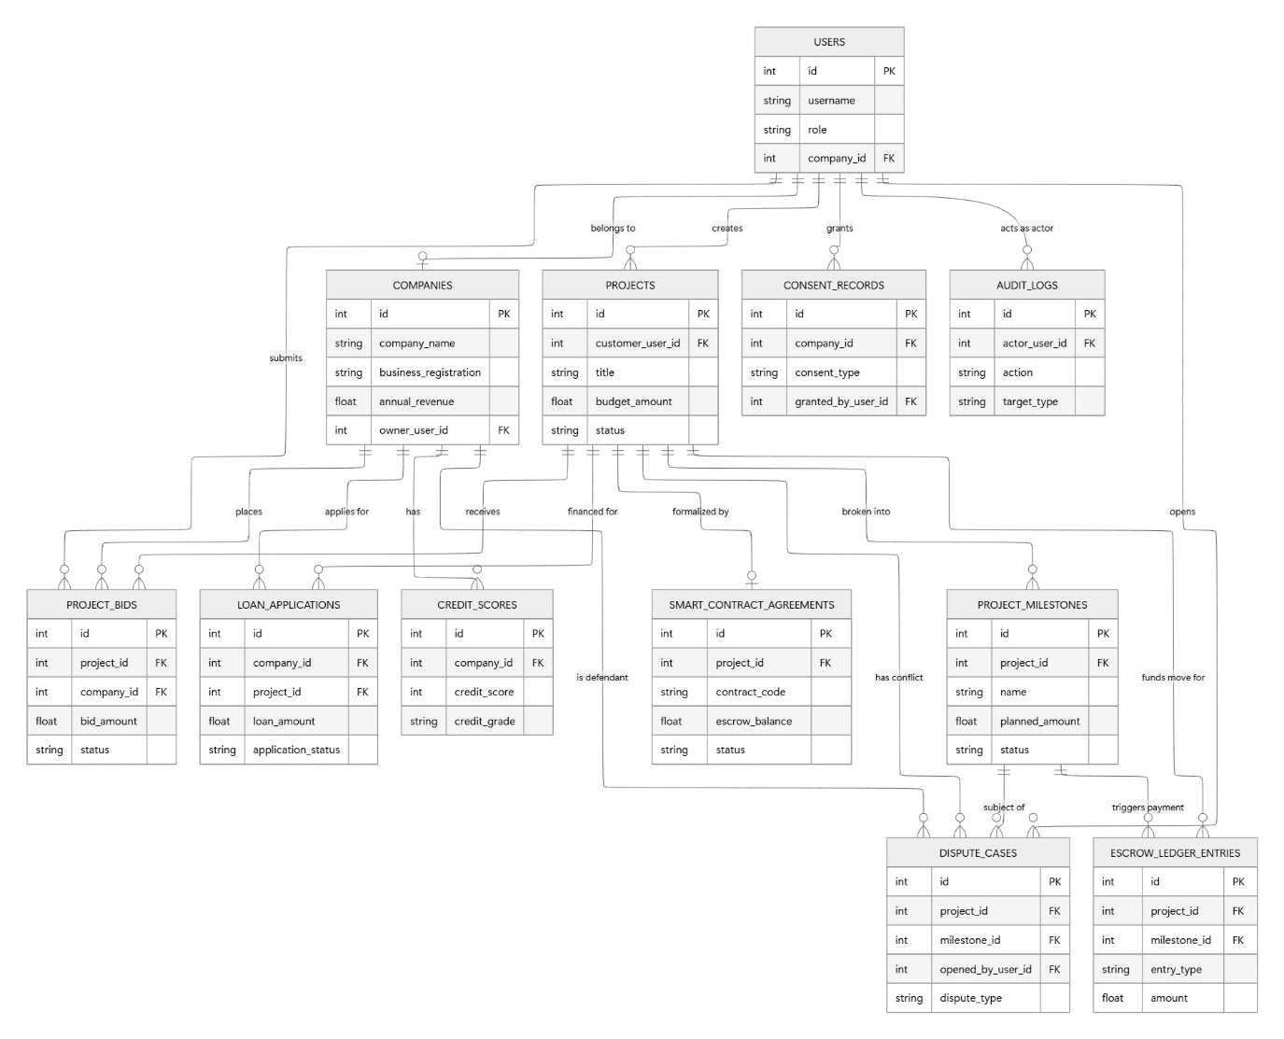

Appendix: Data Dictionary for Database Design
Table: User
Column | Data Type | Nullable | Notes
id | Integer | No | Primary Key
username | String(80) | No | Unique identifier for login
email | String(120) | No | Unique; used for communications
password_hash | String(255) | No | BCrypt/Werkzeug hashed password
role | String(30) | No | Default: 'company_user'
is_active | Boolean | No | Account status toggle
company_id | Integer | Yes | Foreign Key to companies.id
created_at | DateTime | No | UTC timestamp of registration
updated_at | DateTime | No | UTC timestamp of last modification

Table: Company
Column | Data Type | Nullable | Notes
id | Integer | No | Primary Key.
company_name | String(200) | No | Legal name of the company.
company_name_en | String(200) | Yes | English translation of the company name.
business_registration | String(50) | No | Unique Business Registration (BR) number.
company_registration_number | String(50) | Yes | Official registration number.
established_date | Date | Yes | Date the business was incorporated.
registered_capital | Float | Yes | Total declared capital.
contact_person | String(100) | Yes | Primary point of contact.
contact_position | String(100) | Yes | Job title of the contact person.
phone | String(20) | Yes | Contact telephone number.
email | String(100) | Yes | Official company email address.
address | String(300) | Yes | Physical business address.
employee_count | Integer | Yes | Total number of employees.
annual_revenue | Float | Yes | Yearly revenue figure.
project_count_completed | Integer | Yes | History of completed projects.
average_project_value | Float | Yes | Mean value per project.
main_service_type | String(100) | Yes | Primary industry or service provided.
licence_class | String(50) | Yes | Industry license classification.
licence_categories | String(100) | Yes | Categories of services allowed under the license.
licence_expiry_date | Date | Yes | Expiration date of the main license.
licence_verification_status | String(30) | Yes | Status of license review.
osh_officer_role | String(100) | Yes | Role of the Occupational Safety and Health officer.
osh_officer_license_number | String(100) | Yes | License ID for the OSH officer.
insurance_provider | String(100) | Yes | Name of the insurance carrier.
insurance_policy_number | String(100) | Yes | Active insurance policy ID.
insurance_expiry_date | Date | Yes | Expiration date of the insurance policy.
insurance_verification_status | String(30) | Yes | Verification status of the policy documents.
safety_training_coverage | Integer | Yes | Percentage of staff with safety training.
safety_incident_count | Integer | Yes | Total number of recorded safety incidents.
esg_policy_level | String(20) | Yes | Level of Environmental, Social, and Governance policy.
green_material_ratio | Integer | Yes | Percentage of materials sourced sustainably.
owner_user_id | Integer | Yes | Foreign Key to users.id (Primary Owner).
current_assets | Float | Yes | Total liquid assets for financial health analysis.
current_liabilities | Float | Yes | Short-term financial obligations.
total_cash | Float | Yes | Total cash on hand.
total_liabilities | Float | Yes | Overall debt of the company.
shareholders_equity | Float | Yes | Total equity held by shareholders.
audited_financials_uploaded | Boolean | Yes | Indicates if official audited reports are provided.
tax_returns_uploaded | Boolean | Yes | Indicates if tax return documents are provided.
minor_works_contractor_reg | String(100) | Yes | Minor works contractor registration ID.
minor_works_verified | Boolean | Yes | Verification status of minor works registration.
insurance_docs_uploaded | Boolean | Yes | Indicates if policy files are in the system.
insurance_verified | Boolean | Yes | Confirmation of insurance coverage validity.
osh_safety_officer_license | String(100) | Yes | OSH Safety Officer certification ID.
osh_safety_officer_verified | Boolean | Yes | Verification status of the safety officer license.
status | String(20) | Yes | Operational status (active, suspended, blacklisted).
risk_level | String(20) | Yes | Assessment category (low, medium, high).
trust_score_cached | Integer | Yes | Last calculated trust score for quick retrieval.
dispute_count_cached | Integer | Yes | Total number of historical legal/project disputes.
is_verified_for_bidding | Boolean | Yes | Eligibility toggle for participating in projects.
created_at | DateTime | Yes | System timestamp of record creation.
updated_at | DateTime | Yes | System timestamp of last modification.

Table: Project
Column | Data Type | Nullable | Notes
id | Integer | No | Primary Key
customer_user_id | Integer | No | Foreign Key to users.id
title | String(200) | No | Project headline
description | Text | Yes | Detailed project scope
property_type | String(100) | Yes | Classification of property (e.g., Residential, Office).
property_address | String(300) | Yes | Full address of the project site.
district | String(50) | Yes | Geographical district.
budget_amount | Float | No | Estimated total budget
status | String(30) | No | draft, open, awarded, etc.
accepted_bid_id | Integer | Yes | Foreign Key to project_bids.id
target_start_date | Date | Yes | Planned commencement
target_end_date | Date | Yes | Planned completion
created_at | DateTime | No | Record creation timestamp.
updated_at | DateTime | No | Last modification timestamp.

Table: Project Bid
Column | Type | Nullable | Notes
id | Integer | No | Primary Key
project_id | Integer | No | Foreign Key to projects.id
company_id | Integer | No | Foreign Key to companies.id
submitted_by_user_id | Integer | No | Foreign Key to users.id
bid_amount | Float | No | Proposed total cost
status | String(30) | No | submitted, shortlisted, awarded, etc.
proposed_duration_days | Integer | Yes | Estimated timeframe
Proposal_summary | Text | Yes | Summary of the proposed approach.
Nnotes | Text | Yes | Additional bidder remarks.
created_at | DateTime | No | Submisson timestamp.
updated_at | DateTime | No | Last update timestamp.

Table: Smart Contract Agreement
Column Name | Data Type | Nullable | Description / Notes
id | Integer | No | Primary Key.
project_id | Integer | No | Unique Foreign Key to projects.id.
accepted_bid_id | Integer | Yes | Foreign Key to project_bids.id.
customer_user_id | Integer | No | Foreign Key to users.id.
contractor_company_id | Integer | Yes | Foreign Key to companies.id.
contract_code | String(50) | No | Unique contract reference code.
status | String(30) | No | Lifecycle status (e.g., active, completed, disputed).
budget_amount | Float | No | Finalized contract value.
escrow_balance | Float | No | Funds currently held in escrow.
released_amount | Float | No | Total funds paid out to the contractor.
frozen_amount | Float | No | Funds locked due to active disputes.
milestones_total | Integer | No | Total number of defined milestones.
approved_milestones | Integer | No | Count of milestones marked as complete.
dispute_count | Integer | No | Number of disputes raised for this contract.
terms_json | Text | Yes | JSON block containing legal terms.
event_log_json | Text | Yes | JSON audit trail of contract state changes.
created_at | DateTime | No | Agreement creation timestamp.
activated_at | DateTime | Yes | Timestamp when the contract became active.
last_event_at | DateTime | No | Last modification timestamp.

Table: Project Milestones
Column Name | Data Type | Nullable | Description / Notes
id | Integer | No | Primary Key.
project_id | Integer | No | Foreign Key to projects.id.
sequence_no | Integer | No | Order of the milestone (1, 2, 3...).
name | String(200) | No | Title of the milestone.
description | Text | Yes | Detailed criteria for completion.
planned_percentage | Float | Yes | Percentage of total budget assigned.
planned_amount | Float | No | Dollar value of this milestone.
due_date | Date | Yes | Expected completion date.
submitted_at | DateTime | Yes | Timestamp when work was submitted for review.
approved_at | DateTime | Yes | Timestamp of final approval.
status | String(30) | No | Status (e.g., planned, submitted, approved).
evidence_notes | Text | Yes | Contractor notes regarding work evidence.
submitted_by_user_id | Integer | Yes | Foreign Key to users.id (Submitter).
reviewed_by_user_id | Integer | Yes | Foreign Key to users.id (Reviewer).
created_at | DateTime | No | Record creation timestamp.

Table: Escrow Ledger Entry
Column Name | Data Type | Nullable | Description / Notes
id | Integer | No | Primary Key.
project_id | Integer | No | Foreign Key to projects.id.
milestone_id | Integer | Yes | Foreign Key to project_milestones.id.
entry_type | String(30) | No | Type (e.g., deposit, release, refund, fee).
amount | Float | No | Transaction amount.
currency | String(10) | No | Transaction currency.
status | String(30) | No | Transaction status (e.g., active, pending).
reference_note | String(255) | Yes | Internal reference or tracking notes.
created_by_user_id | Integer | Yes | Foreign Key to users.id (Triggering user).
created_at | DateTime | No | Transaction timestamp.

Table: Loan Application
Column Name | Data Type | Nullable | Description / Notes
id | Integer | No | Primary Key.
company_id | Integer | No | Foreign Key to companies.id.
project_id | Integer | Yes | Foreign Key to projects.id.
loan_amount | Float | No | Principal amount requested.
loan_purpose | String(200) | Yes | Stated reason for the loan.
loan_term_months | Integer | Yes | Repayment duration in months.
expected_interest_rate | Float | Yes | Initial interest rate expectation.
collateral_type | String(100) | Yes | Type of assets pledged.
collateral_value | Float | Yes | Estimated value of collateral.
guarantor | String(200) | Yes | Name of the loan guarantor.
bank_name | String(100) | Yes | Name of the financing institution.
bank_officer | String(100) | Yes | Primary bank contact.
bank_reference_number | String(50) | Yes | Bank's internal application ID.
application_status | String(30) | Yes | Status (e.g., under_review, approved, rejected).
approval_date | Date | Yes | Date loan was officially approved.
approved_amount | Float | Yes | Final authorized principal.
approved_interest_rate | Float | Yes | Final agreed interest rate.
approval_conditions | Text | Yes | Legal conditions for the loan.
credit_score_at_app | Integer | Yes | Credit score at time of application.
credit_grade_at_app | String(5) | Yes | Credit grade at time of application.
disbursement_date | Date | Yes | Date funds were released.
disbursement_amount | Float | Yes | Amount released to the borrower.
first_repayment_date | Date | Yes | Scheduled start of repayment.
repayment_status | String(30) | Yes | Repayment health (e.g., current, overdue).
total_repaid | Float | Yes | Total amount paid back to date.
outstanding_balance | Float | Yes | Remaining principal and interest.
overdue_days | Integer | Yes | Number of days repayment is late.
applied_at | DateTime | Yes | Date and time application submitted.
updated_at | DateTime | Yes | Last record modification.
notes | Text | Yes | Miscellaneous administrative notes.
rejection_reason | Text | Yes | Explanation for rejected applications.
reviewed_by_user_id | Integer | Yes | Foreign Key to users.id (Loan officer).
decision_at | DateTime | Yes | Timestamp of final decision.

Table: Credit Score
Column Name | Data Type | Nullable | Description / Notes
id | Integer | No | Primary Key.
company_id | Integer | No | Foreign Key to companies.id.
financial_score | Integer | Yes | Score for financial strength (0-600).
operational_score | Integer | Yes | Score for operational stability (0-250).
qualification_score | Integer | Yes | Score for certifications (0-200).
customer_review_score | Integer | Yes | Score for reputation (0-300).
credit_score | Integer | Yes | Final weighted score (0-1000).
credit_grade | String(5) | Yes | Final grade (e.g., AAA, BBB).
risk_level | String(20) | Yes | Qualitative risk assessment (Low/High).
risk_factors | Text | Yes | Key drivers behind the risk assessment.
recommended_loan_limit | Float | Yes | Maximum suggested financing amount.
recommended_int_rate | Float | Yes | Suggested interest rate based on score.
scoring_model_version | String(20) | Yes | Version of the scoring algorithm used.
scored_at | DateTime | Yes | Calculation timestamp.
expires_at | DateTime | Yes | Expiration date of this assessment.
notes | Text | Yes | Scoring officer remarks.

Table: Consent Record
Column Name | Data Type | Nullable | Description / Notes
id | Integer | No | Primary Key.
company_id | Integer | No | Foreign Key to companies.id.
consent_type | String(50) | No | Type of authorization (e.g., credit check, data sharing).
granted_by_user_id | Integer | No | Foreign Key to users.id (The authorizing individual).
granted_at | DateTime | No | Timestamp when the consent was recorded.
status | String(30) | No | Lifecycle status (e.g., granted, revoked).
notes | Text | Yes | Additional context or limitations regarding the consent.

Table: Audit Log
Column Name | Data Type | Nullable | Description / Notes
id | Integer | No | Primary Key.
actor_user_id | Integer | Yes | Foreign Key to users.id (The person who performed the action).
action | String(120) | No | Description of the activity (e.g., "submit_bid", "approve_milestone").
target_type | String(80) | No | The entity type affected (e.g., "Project", "LoanApplication").
target_id | Integer | Yes | The Primary Key ID of the specific entity modified.
details_json | Text | Yes | A JSON string containing "before and after" data or metadata about the event.
created_at | DateTime | No | System timestamp of the logged event.

Table: Dispute Case
Column Name | Data Type | Nullable | Description / Notes
id | Integer | No | Primary Key.
project_id | Integer | No | Foreign Key to projects.id.
milestone_id | Integer | Yes | Foreign Key to project_milestones.id (if the dispute is stage-specific).
opened_by_user_id | Integer | No | Foreign Key to users.id (The person who initiated the case).
against_company_id | Integer | Yes | Foreign Key to companies.id (The company being disputed).
dispute_type | String(100) | No | Category of dispute (e.g., "Quality", "Delay", "Payment").
description | Text | No | Detailed explanation of the issue provided by the claimant.
status | String(30) | No | Current state (e.g., open, under_review, resolved, closed).
resolution_summary | Text | Yes | Final outcome or settlement details once resolved.
opened_at | DateTime | No | Timestamp when the case was created.
resolved_at | DateTime | Yes | Timestamp when the case status was moved to resolved.

Division of tasks
Name | Core Tasks, Responsibility and Contribution
LAM Chun-hong, Laurance (25401424) - (Team Leader) | Role: Team Leader & Product Manager  Key Contributions:  - Defined the product vision and strategic framework underpinning the business model.  - Conducted comprehensive market research and competitive analysis to inform product positioning.  - Designed core user workflows and operational logic, mapping end-to-end journeys from user interaction to algorithmic processing.  - Established the evaluation criteria and rationale for key algorithms and performance metrics.  Responsibility Chapter in Report:  - Abstract  - Introduction and Background  - Business Model  - Key Algorithm & Assessment Rationale  - System Architecture and Workflow (vertical swimlane diagrams)  Responsibility Chapter in Presentation:  - Introduction and Background  - Business Model  - Key Algorithm & Assessment Rationale

ZHANG Xin-yue (25409883) | Role: Frontend/UI Designer  Key Contributions:  - Implemented the dual-UI architecture (Default App + New UI Prototype)  - Standardized visual styles and fixed interface display issues  - Optimized role-specific pages for customer, company, and admin  - Designed and implemented the complete Customer-to-Company-to-Admin main workflow  Default Demonstration Version: Rectified a series of UI issues (chaotic layout, abnormal component display, irregular interaction) across all user-facing pages, ensuring the normal operation of the project’s on-site demonstration. Key deliverables include visual standardization, display error resolution, and cross-role interface adaptation for all core workflows (project bidding, milestone management, loan application, audit logging).  New UI Prototype Version: Leding the end-to-end design and development of a complete, role-oriented high-fidelity prototype, covering user-facing display modules (customer project management, company dashboards), background management modules (admin audit logs, company comparison), and data verification modules (trust score reporting, compliance tracking). This prototype provides a standardized, feature-complete reference for the project’s subsequent iteration and function expansion, with all design decisions validated by actual user workflow requirements.  Cross-team Collaboration: Cooperated with backend developers to complete the interface connection between the UI layer and backend functional modules, ensuring the unity of the project’s visual effect and functional logic across both UI versions.  Responsibility Chapter in Report:  - Frontend development  Responsibility Chapter in Presentation:  - Frontend development

Gao Cheng-you (25401254) | Role: Backend Developer  Key Contributions:  - Backend development  Responsibility Chapter in Report:  - Backend development  Responsibility Chapter in Presentation:  - Backend development

LAM Cheuk-sze, Tracy (25472143) | Role: DB Engineer & QA  Key Contributions:  - Database design & Engineering  - Relational Schema Design  - Performance Optimization  - Data Integrity  - Security Posture  - Automated Quality Assurance and Systematic Validation  - Algorithmic Validation  - Resilient E2E Testing  - State Management  - Integrated File Verification  - System Stability  - Workflow Adjustment  Responsibility Chapter in Report:  - Database design & Engineering  - Automated Quality Assurance and Systematic Validation  - Workflow Adjustment  Responsibility Chapter in Presentation:  - Database Architecture  - Automated

TIU Kwai-ming, William (25470019) | Role: System Architecture, Technical Coordinator & Compliance  Key Contributions:  - Proof of Concept (PoC)  - System Architecture: Developed the foundational codebase to establish the Proof of Concept (PoC).  - Repository: Accessible via GitHub:  - https://github.com/williamtiu/renovation-credit-system/  - Documentation & Presentation Integration  - Coordinated the synthesis of technical report findings with PowerPoint presentations to ensure architectural consistency.  - System deployment for Testing  Deployed a live web-based testing environment for real-world application validation  (available up to 30 Apr 2026):  - CoreLogic/Functionality: app1.techwilliam.com  - UI/UX Preview:  app1.techwilliam.com/new-ui/  - Development Support  - Conducted technical research and assisted in the full-stack development of frontend and backend modules.  Responsibility Chapter in Report:  - IT Security and Risk Assessment  - Compliance and Governance Framework  - Future Development Strategic Roadmap  - Conclusion  Responsibility Chapter in Presentation:  - IT Security and Risk Assessment  - Compliance and Governance Framework  - Future Development Strategic Roadmap  - Conclusion

AM730 (2024), 裝修爛尾｜裝修中伏由74萬變117萬, https://www.am730.com.hk/article/482415 (Accessed 2026-04-09)
Yahoo (2022), $29萬裝修爛尾，苦主慘被收數公司纏繞, https://hk.finance.yahoo.com/video/胡-說樓市-29萬裝修爛尾-苦主慘被收數公司纏繞-020000591.html?soc_src=social-sh&soc_trk=ma, (Accessed 2026-04-09)
Rating and Valuation Departmnet (2026), Domestic Primary And Secondary Sales - Number Of Sale And Purchase Agreements And Total Consideration, https://www.rvd.gov.hk/doc/en/statistics/his_data_16.xls (Accessed 2026-04-09)
Consumer Council (2024) - Home Renovation Industry – Better Governance for Creating Comfortable Homes (Page 65 & 66), https://www.consumer.org.hk/en/advocacy/study-report/home_renovation_study (Accessed 2026-04-09)
Consumer Council (2024) (Page viii)
Consumer Council (2024) (Page 70)
Companies Registry - Licensing of Money Lenders - Information for Borrowers / Intending Borrowers - Search on List of Third Parties Appointed by Licensed Money Lenders (2026), https://www.cr.gov.hk/en/services/money-lenders/search/third-parties-search.htm (Accessed 2026-04-09)
Consumer Council (2024) (Page 7)
Consumer Council (2024) (Page 33)
Included to assess short-term liquidity: a ratio >1.6 indicates the contractor can comfortably cover immediate obligations (e.g., materials, subcontractor payments) without relying on new customer deposits, reducing the risk of project interruption due to cash flow shortages.
Included as the most conservative liquidity measure: it evaluates whether a contractor can meet all liabilities using only cash and cash equivalents. This is critical in renovation projects where unexpected costs or delays may arise, and immediate cash availability ensures work continuity without jeopardizing project completion.
Included to evaluate financial leverage and long-term solvency: a lower ratio (<1.0) indicates the contractor relies more on owner equity than borrowed funds, suggesting greater financial resilience and lower risk of insolvency during extended project timelines.
Building Department (2026) - Introduction to Minor Works Control System - Buildings Department, https://www.bd.gov.hk/en/building-works/minor-works/introduction-to-minor-works-control-system/index.html (Accessed 2026-04-09)
Consumer Council (2024) (Page 9)
Consumer Council (2024) (Page 81)

